Sensor integration tutorial

## Boat prep

1. Test drive the boat.
   1. Set everything to a slow speed.
   2. Make sure the boat can turn and go backwards.
   3. Watch for how low/high the boat sits in the water.

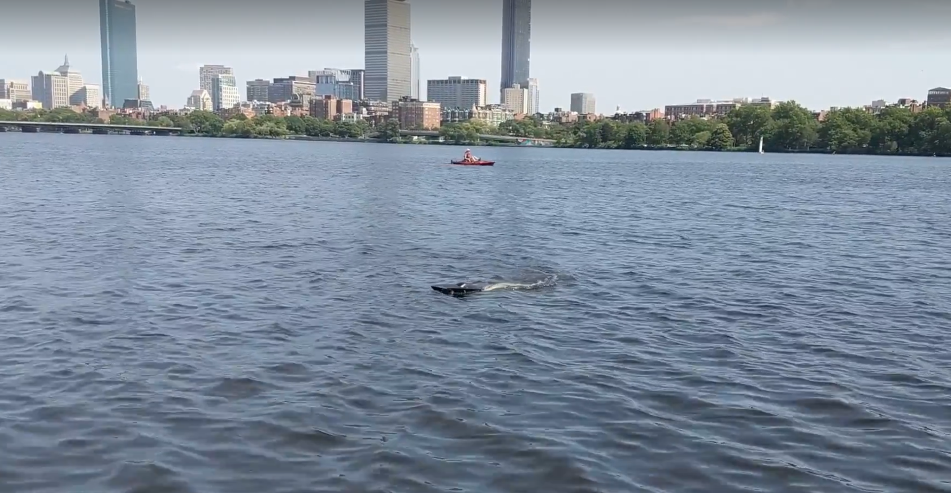 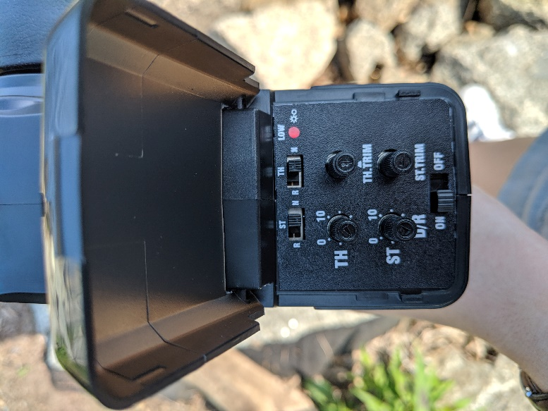

This was a test drive of the boat to see how much of the boat is in the water while it’s driving. The image on the right shows the settings which allowed us to drive at a reasonable speed, turn, and move forwards and backwards.

1. Remove the stickers from the boat.
   1. The best way we came up with was to use rubbing alcohol. Let the sticker soak in the rubbing alcohol for a few minutes before removing the glue goop.
2. Sand the boat.
   1. Use a fine sandpaper at the end, because the spray paint doesn’t hide the sanding marks.
3. Tape up the rudder, antenna, etc., so they don’t get spray painted.

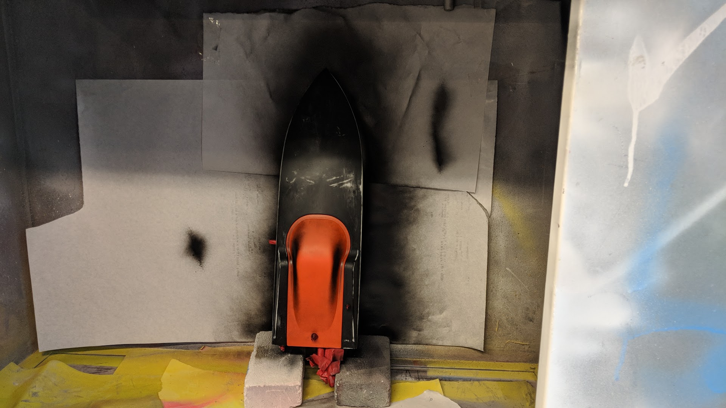

This is what the boat looks like post-sticker removal and post-sanding. The top hasn’t been spray painted yet, but you can also see how the rubber is taped up.

1. Spray paint the boat.
   1. A couple layers will probably be needed, let the boat dry completely between coats so drips don’t occur.

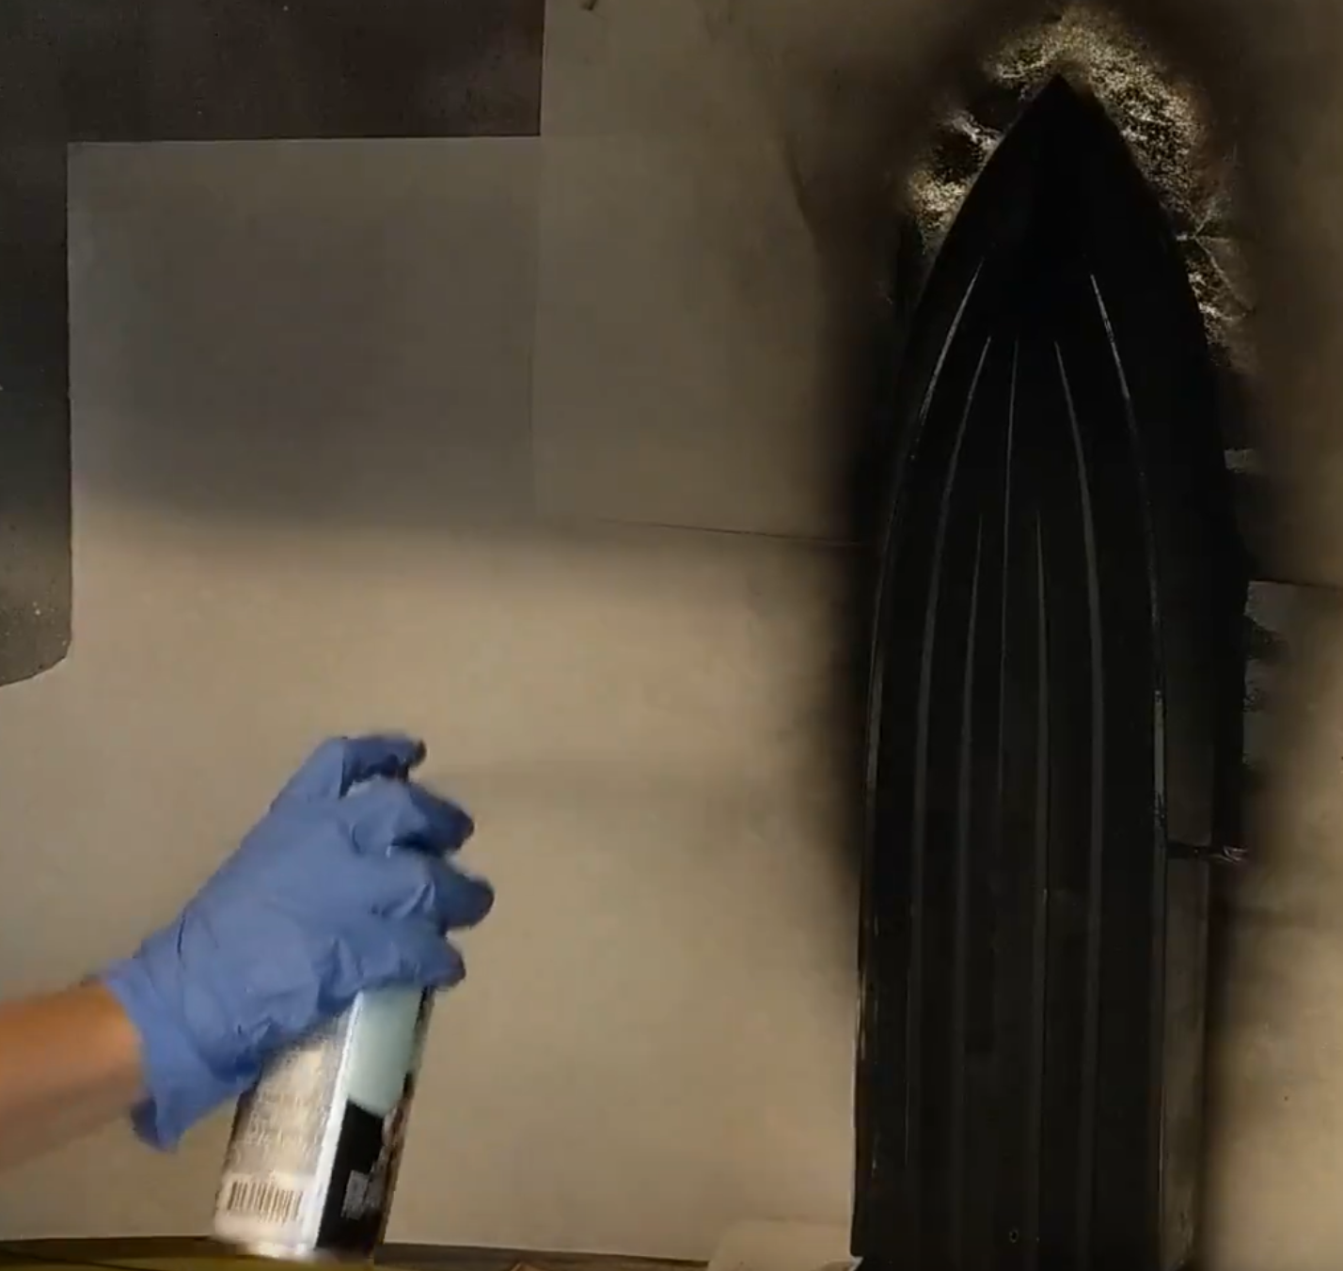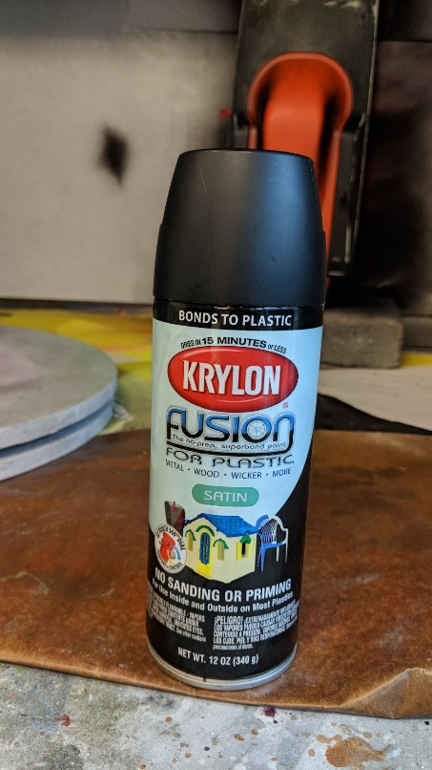

Here is us spray painting the bottom of the boat, and the spray paint we used. We tried to stay about 6 inches away from the surface while we were spraying.

# order of installation

1. Cut out the LED panels.
2. Install the pH sensor (involves drilling, so should be done with nothing extra in the boat).
3. Install the rest of the sensors (easier to thread wires using the holes for the LEDs).
4. Install the LEDs.

# Labeling scheme between sensors

We added tags on the wires of each of the probes close to the header so we can be sure we’re plugging the right sensor into the right port on the Feather. They are color coded as the following:

LEDs 🡪 yellow Conductivity 🡪 green Temperature 🡪 orange

Turbidity 🡪 pink pH 🡪 blue

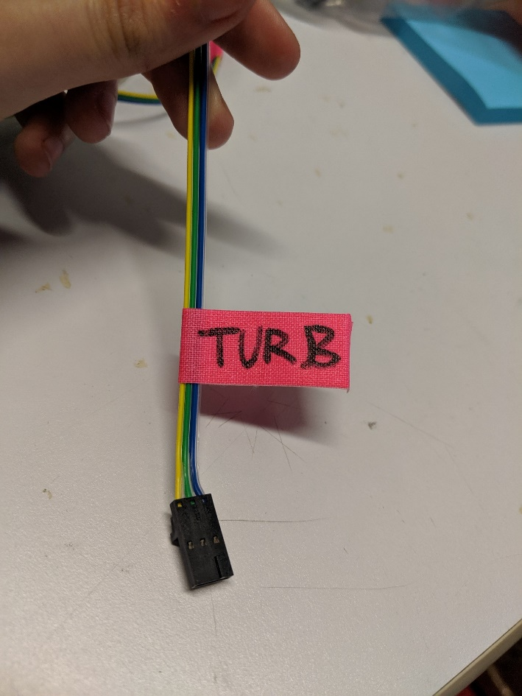

This is what the tag looks like.

## LED strips

### cutting out the panels

1. Cut LED acrylic on the laser cutter.
2. Use blue tape to outline where you’re going to cut on the boat.
   1. Make sure the cut-out is within the acrylic area and has a good amount of margin (we used ~0.25 inch from each edge.
   2. Make sure the surface is as flat as possible.
   3. Make sure the cut wouldn’t hit anything inside the boat.
   4. Make sure the cut is reasonably above the water line.
   5. Double check everything!

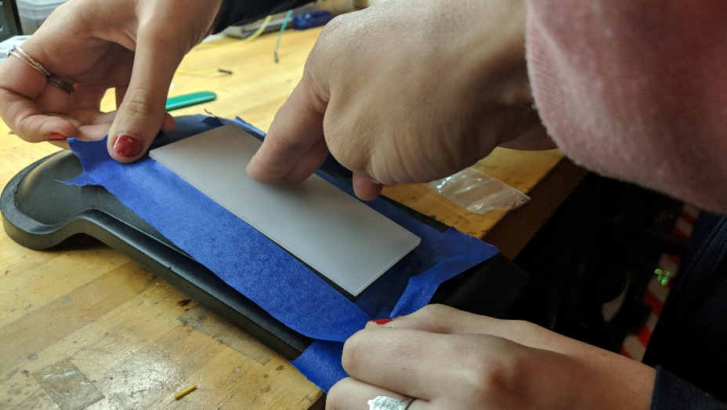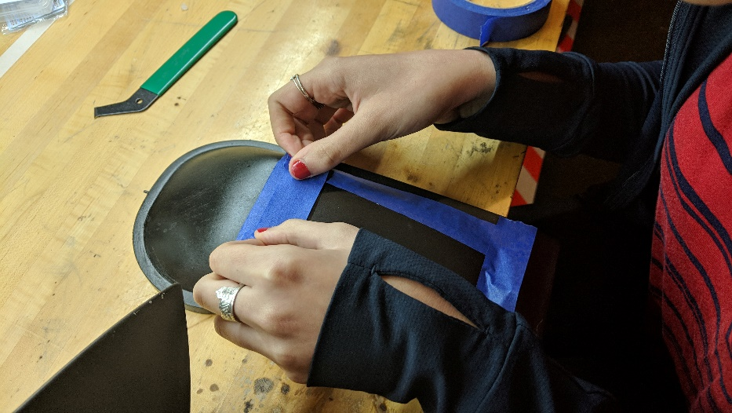

The image on the left shows us outlining the acrylic with blue tape. Then (on the right) we moved each side in about a quarter of an inch so there would be overlap to glue the panels to.

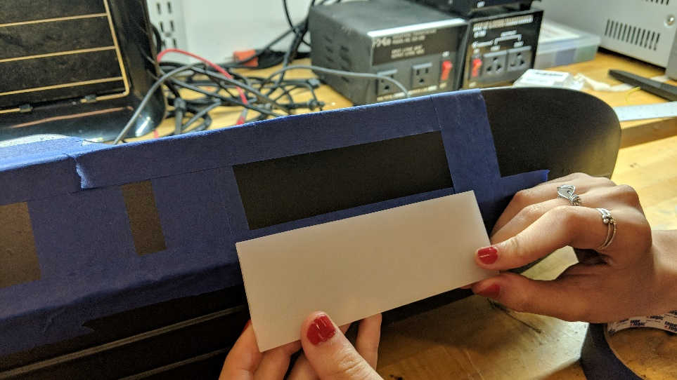 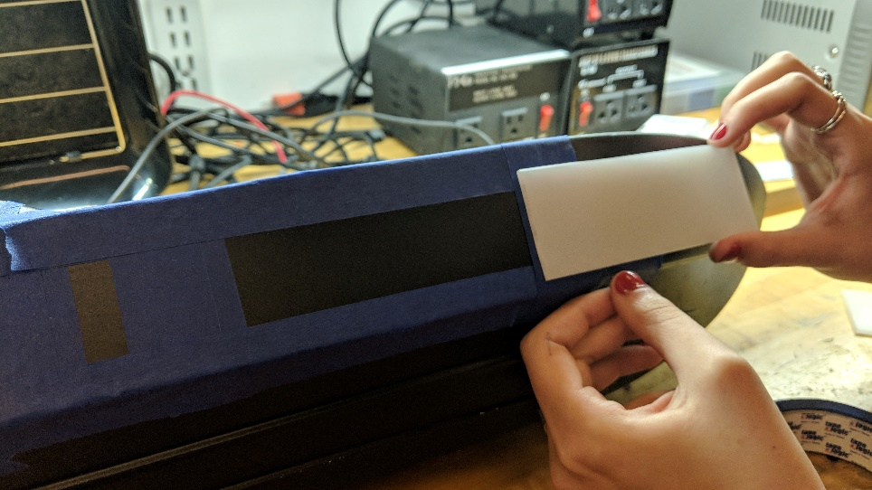

These images show that the panels will cover the cut-outs with a good amount of margin for gluing.

1. Tape things down inside the boat so you don’t nick them.
2. Cut along the inner edge of the tape with the box cutter/plastic cutter.
   1. On you first pass go lightly.
   2. Keep your other hand out of the way!
   3. If the knife gets stuck, ease up on the pressure. If you push too hard you might lose control of the knife.
   4. Don’t cut all the way through any one side of the panel until they are all mostly cut through, because once they’re cut out the boat loses some of its structural strength and gets more ‘bendy’ which makes it harder to cut.
   5. Once the panels are mostly cut through, you can snap off the plastic.

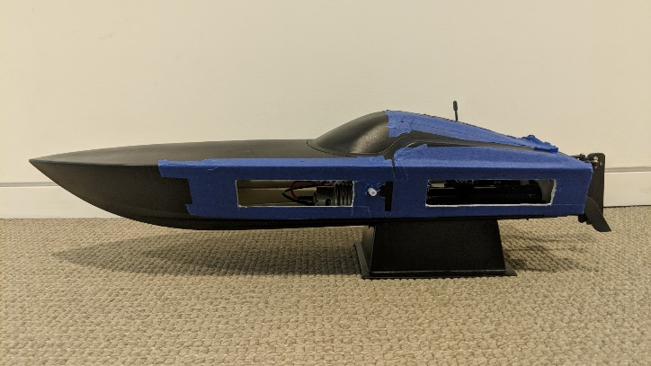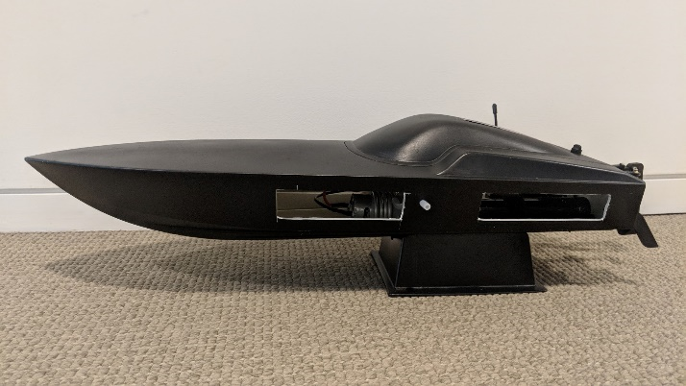

The boat with LED panels cut out, before and after we removed the blue tape around the edges.

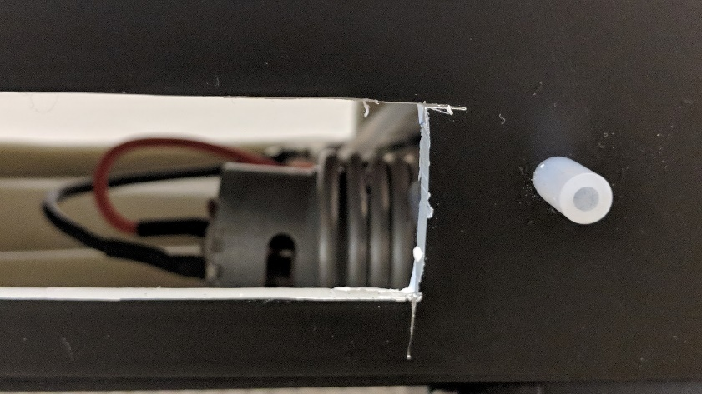

Here’s a close-up of one of the panel cut-outs. Sometimes it’s hard to control the plastic cutter from going too far, especially right at the corners. Don’t stress too much about it; most of those nicks will be covered by the acrylic panels. Try to avoid them anyway!

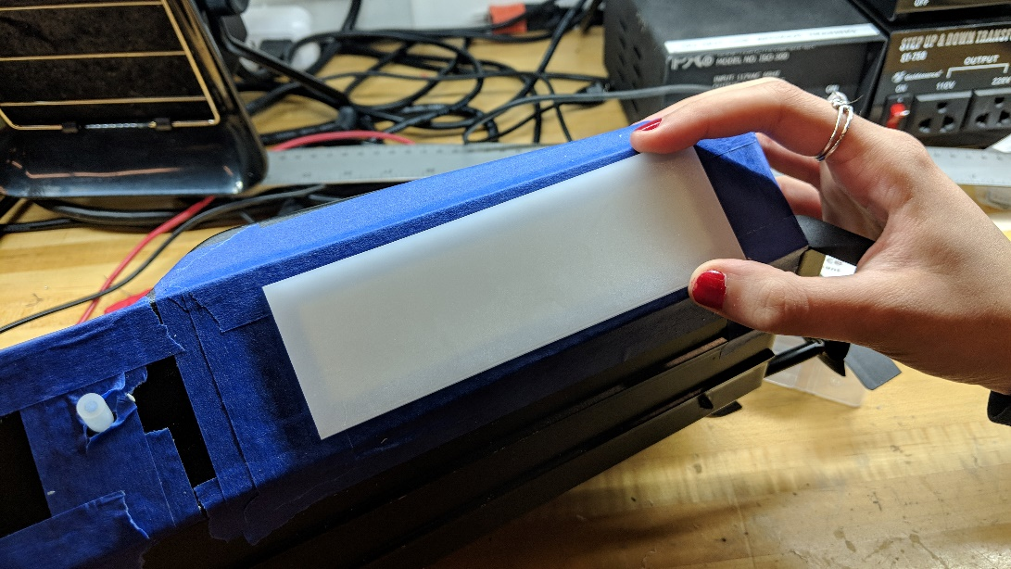

After the hole is cut out, hold up the panel against it to see if everything is lined up correctly.

1. On the top panel, melt a hole for the pH wire.

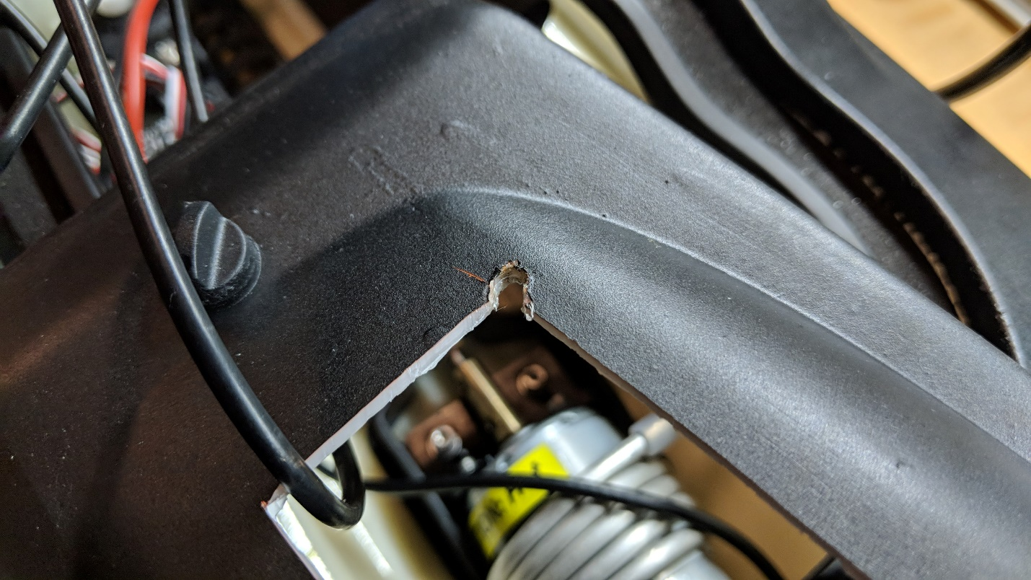

The melted hole for the pH wire.

### led strip set-up

1. Cut the LED strips to the correct lengths and rewire them.
   1. Be careful when doing this as if rewired incorrectly all the LEDs will burn out and the strip will be ruined!

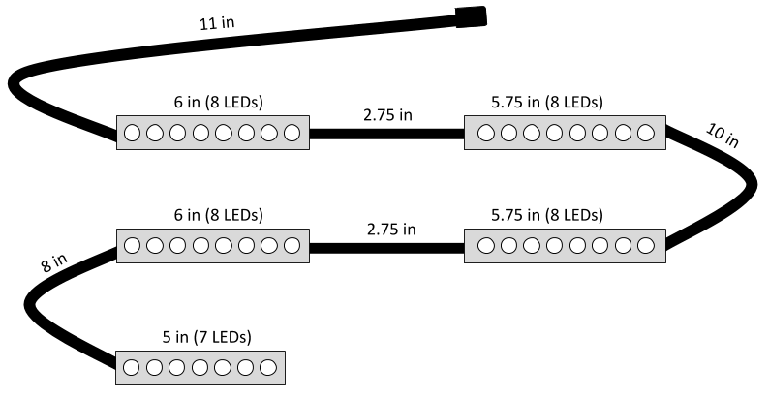

These are the LED strip lengths and connecting wires lengths you should follow.

1. Test the strip!
   1. Make sure to have a battery connected.
   2. Check for any loose strands of wire.
   3. Add extra solder if it seems the current isn’t reaching some of the LEDs.
   4. Try reconnecting to the other side of the strip.
   5. Make sure in the code that the number of pixels is correct.
2. Silicone glue the ends of the strips.

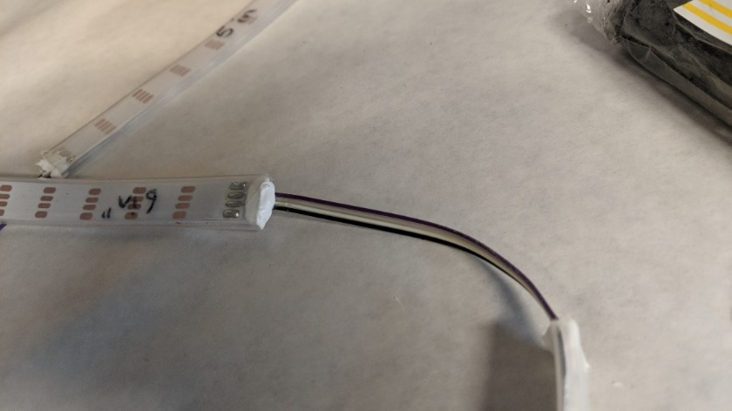

A sealed LED strip.

1. Make LED ‘legs.’

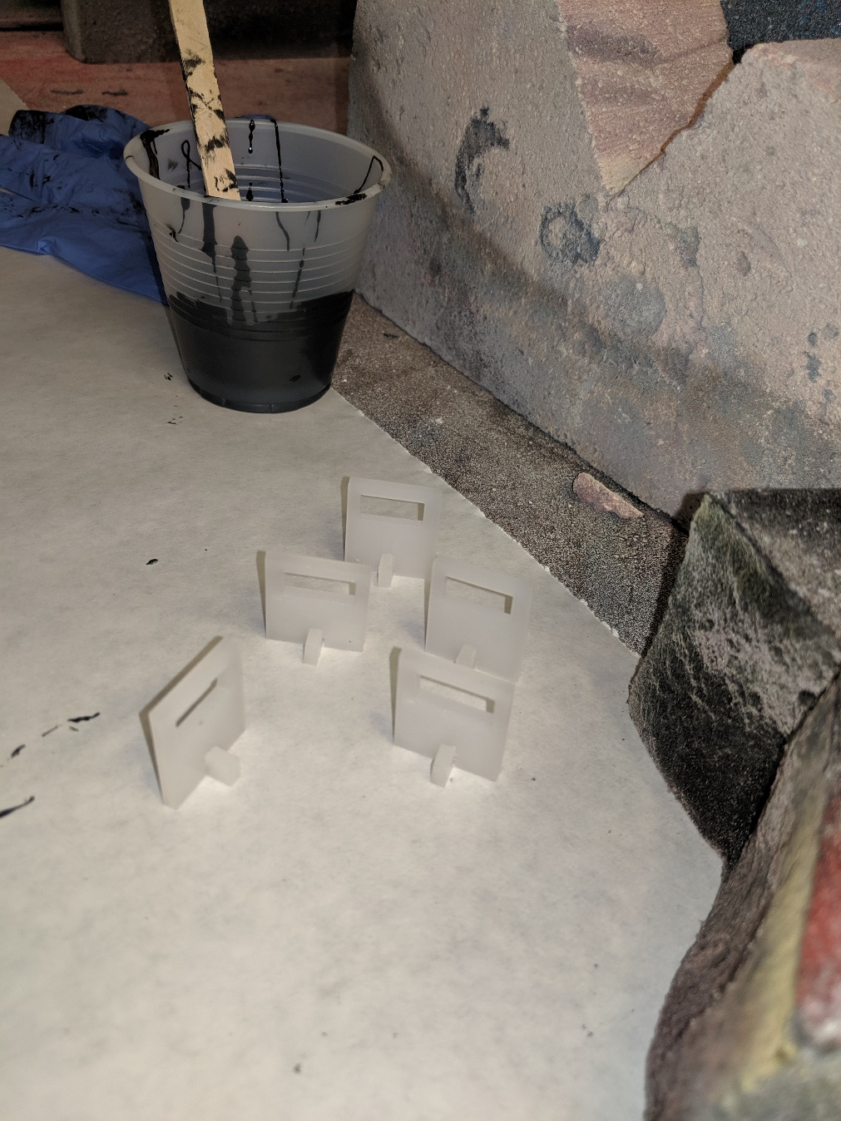

This is what the legs look like after being glued with acrylic glue.

1. Mark on the acrylic where the legs should go on each panel using the cut-outs in the boat.

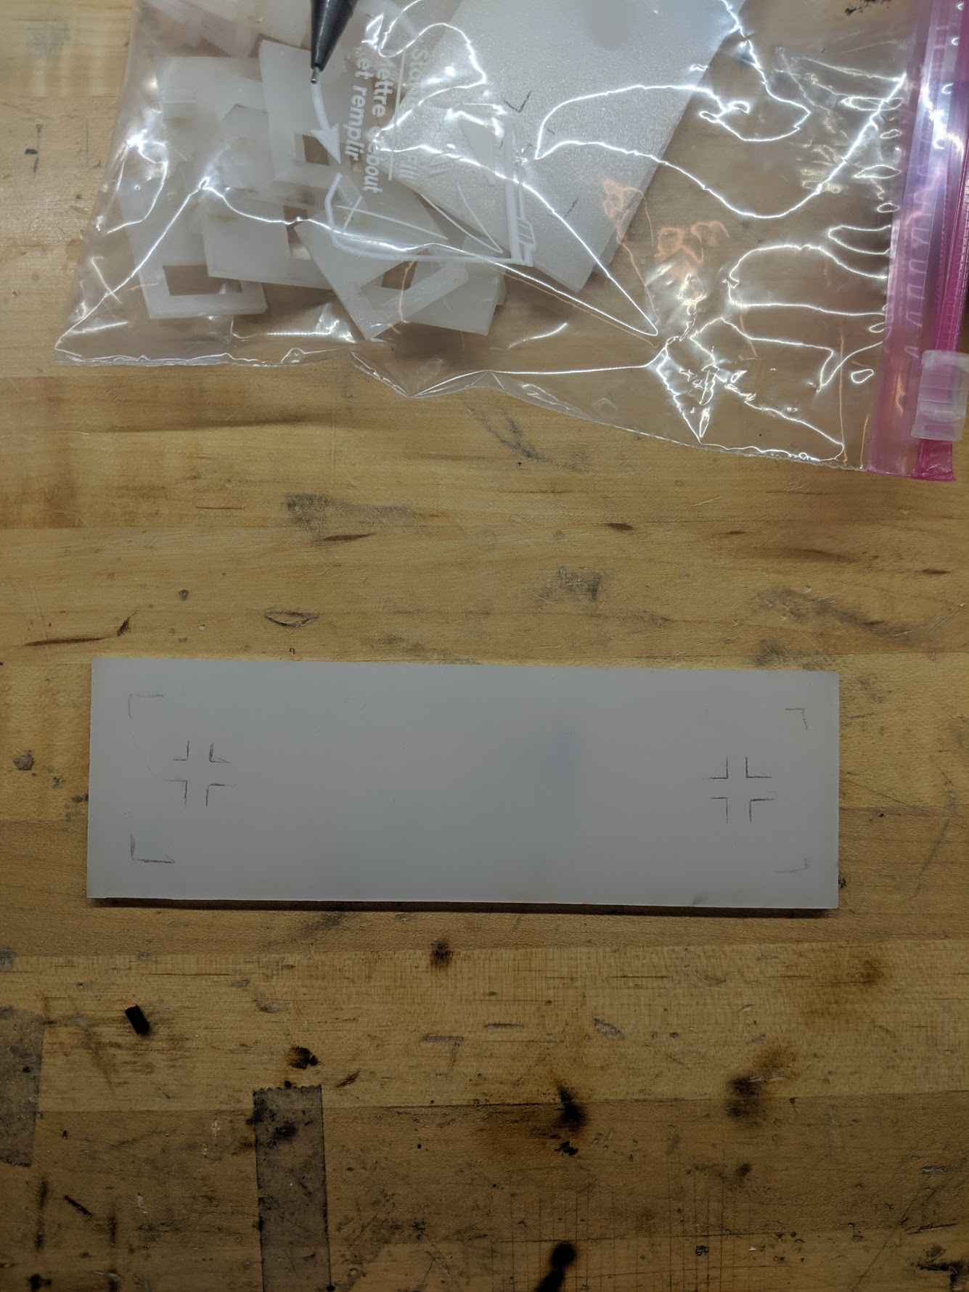

Here is an example of what one of our marked-up panels looks like.

1. Acrylic glue the legs down to the panels.

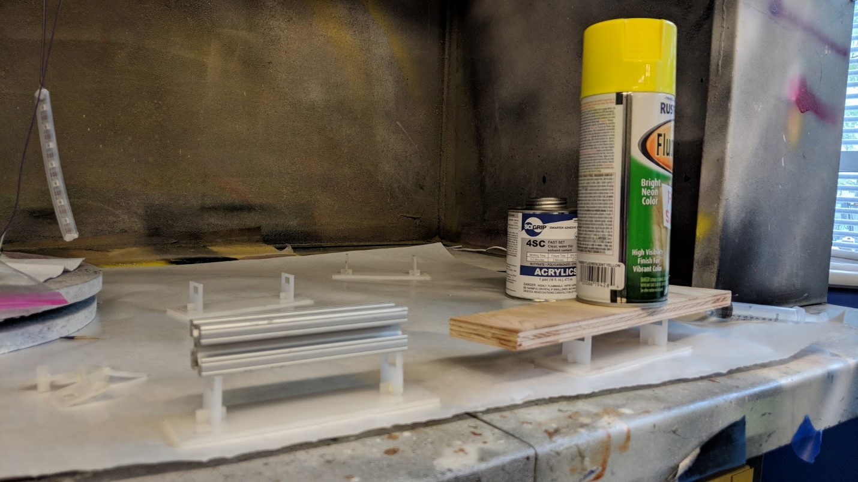

It helps when acrylic-gluing the legs on to put a weight on top of them; the glue needs to cure for a few minutes with pressure.

1. Thread the strips through the boat.

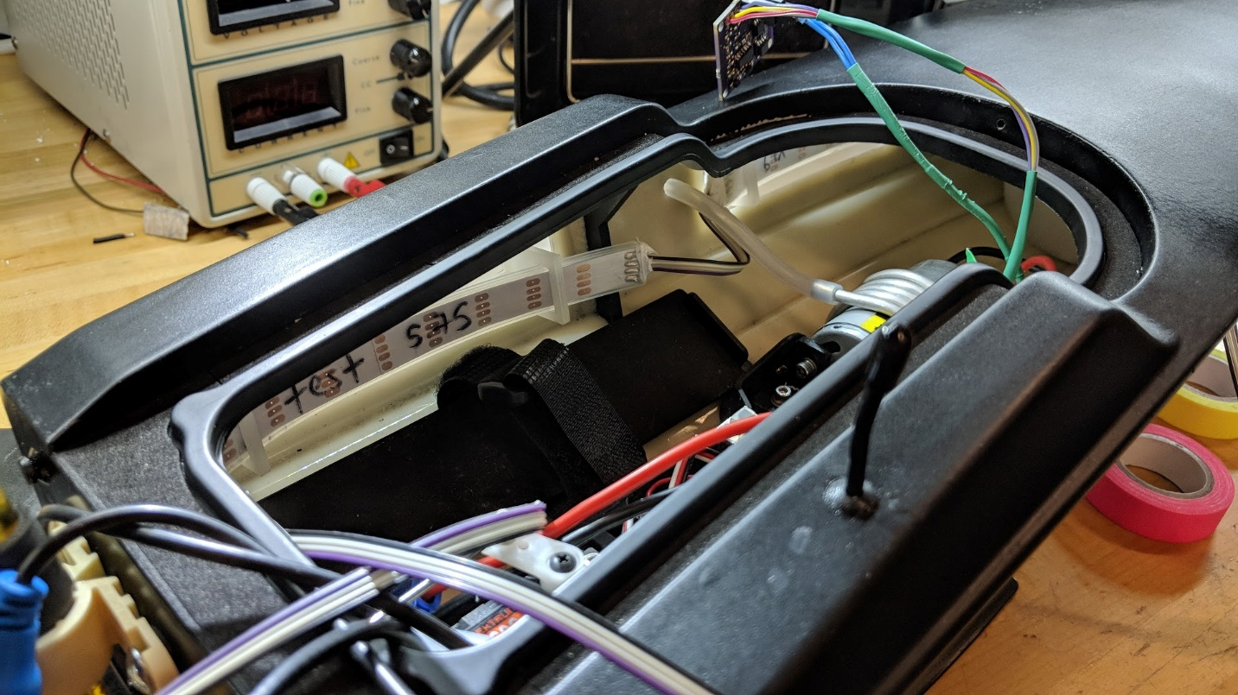

This is what the interior of the boat should look like once the LEDs have been threaded through the panels.

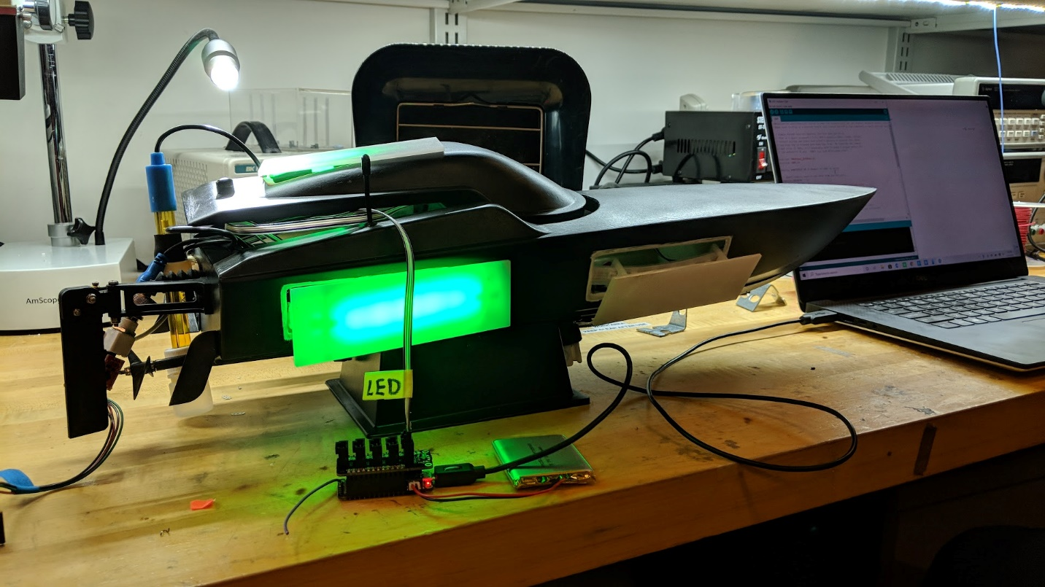

After threading the strand and before gluing the panels in place, we testing the LEDs again.

### attaching the panels

1. Sand edges of cut-outs on the boat; make sure to get the paint off.

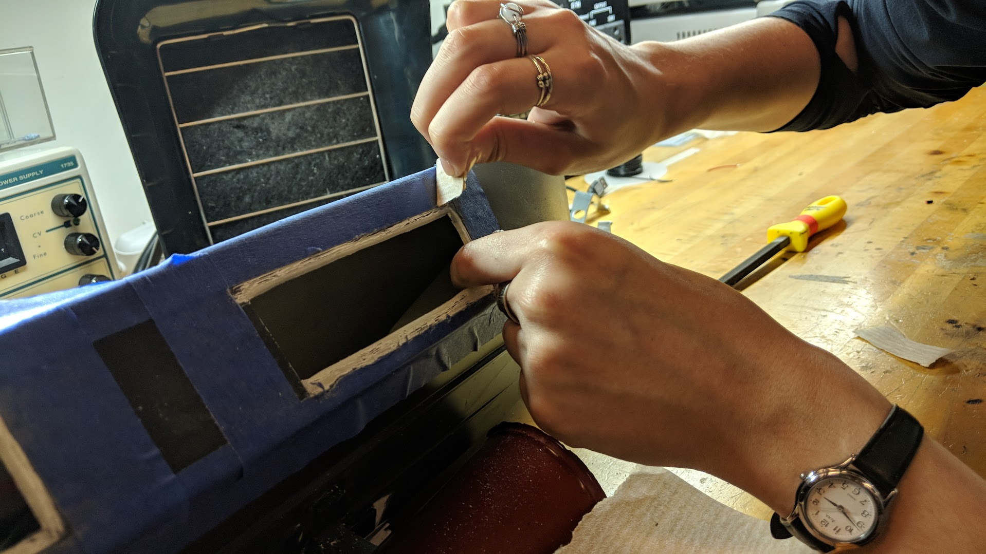

We used blue tape to mark how much we wanted to sand. Notice how we sanded all the black paint off, until we reached the white plastic core.

1. Sand edges of LED acrylic.
2. Wipe down sanded surfaces to get rid of dust.
3. Epoxy the key areas of the panels (bottoms of side panels because they’re submerged in water).
   1. Use the plastic-plastic epoxy.
   2. Since the surface isn’t completely flat everywhere, there might be places where the panel sticks out and the epoxy doesn’t reach. To help solve this problem, you can try to fill some of the gap with the epoxy, and later on fill it with silicone glue.

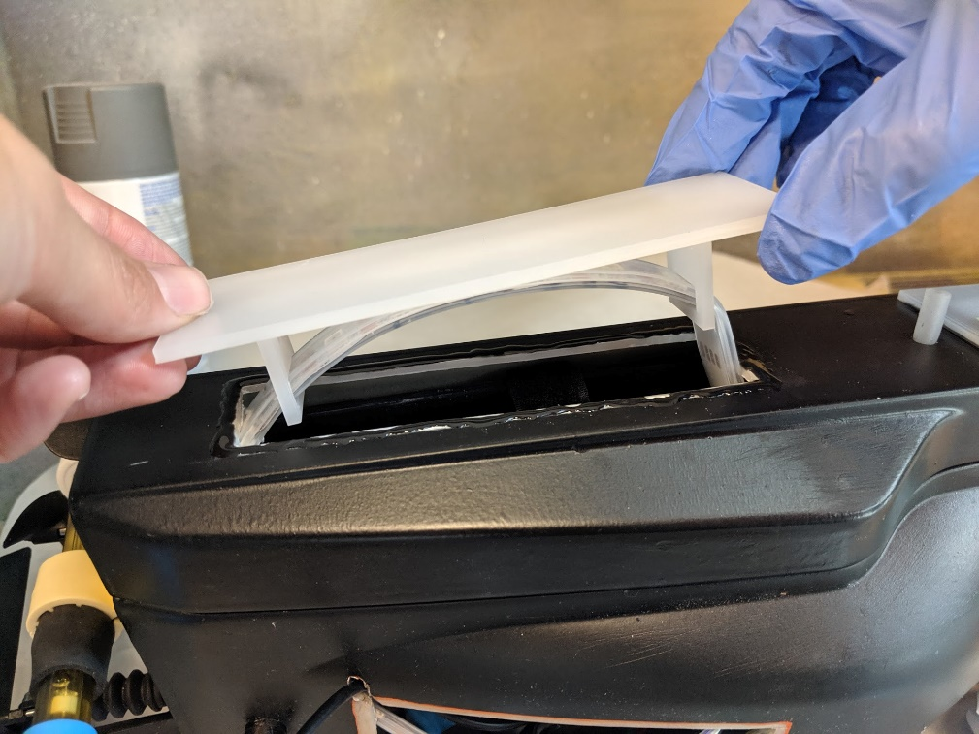

We covered the sanded edge of the boat with epoxy, and carefully lowered the panel until it met the epoxy. We propped the boat up with a couple of bricks so the surface was parallel to the ground.

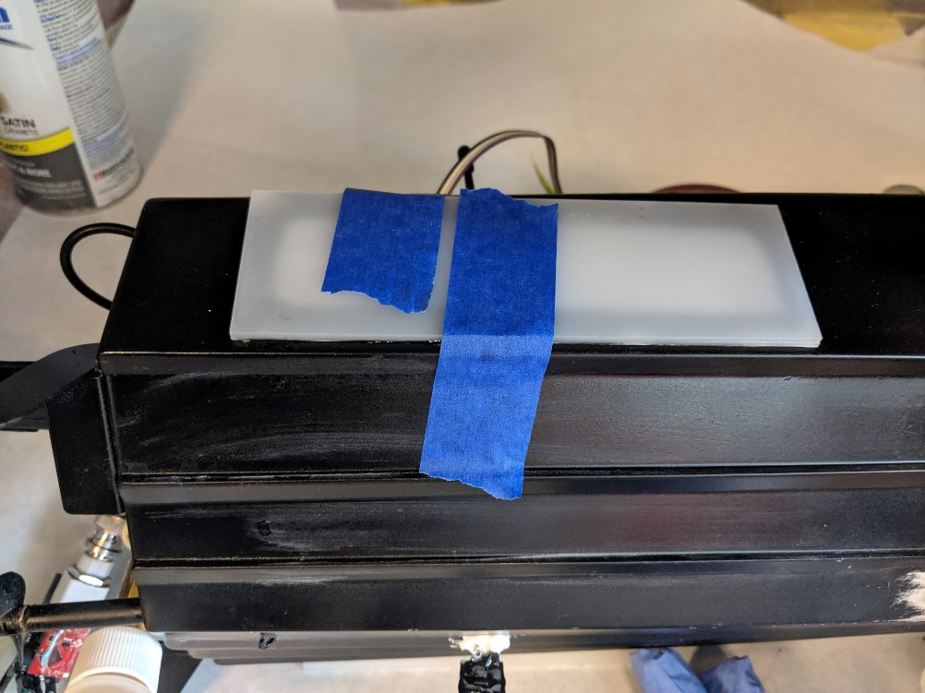

After holding the panel on by hand for a minute, we taped the panel to the boat to continue curing. Make sure to pull the tape taut so it doesn’t move.

1. Seal edges with silicone glue.

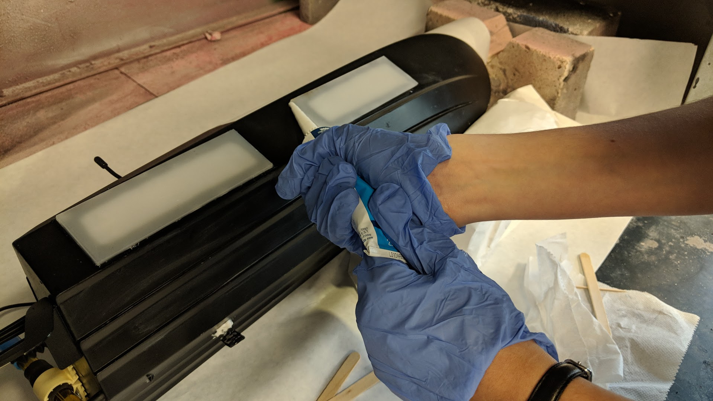

We cut the nozzle at an angle, and went around each edge of the panel with a line of silicone glue. We then smoothed it over with a popsicle stick to ensure that there were no bubbles.

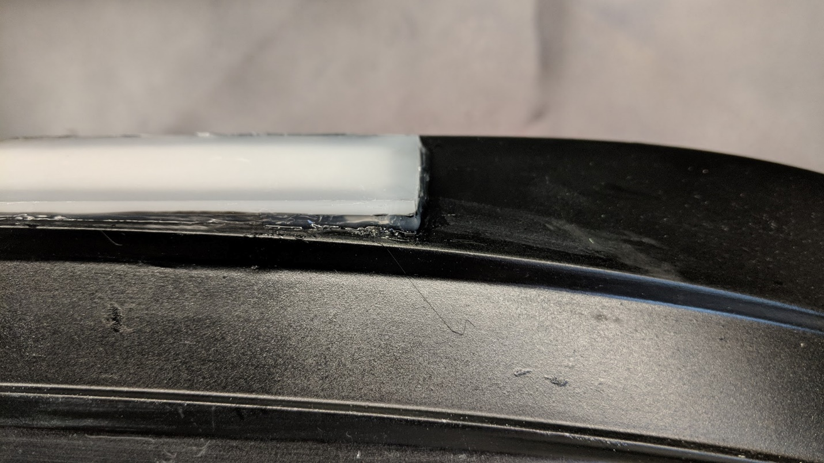

Here is one of the corners which is not flush with the side of the boat due to the curve that you can see in the photo. We added extra silicone glue to fill in the gap and seal up the hole.

## pH

1. Wrap a rubber band around the probe to make it a little thicker and have more friction.
2. Cut a small length of rubber tubing and pull it over where the rubber bands are.
3. Put the clamp around the probe.
4. Mark on the boat where the holes for the screws will be.
5. Drill 2 holes.
   1. We used a 29 drill bit.
6. Screw the clamp onto the boat.
   1. Order on screws: clamp 🡪 foam o-ring 🡪 boat 🡪 foam o-ring 🡪 nut (look at the images below)
   2. Use Loctite!

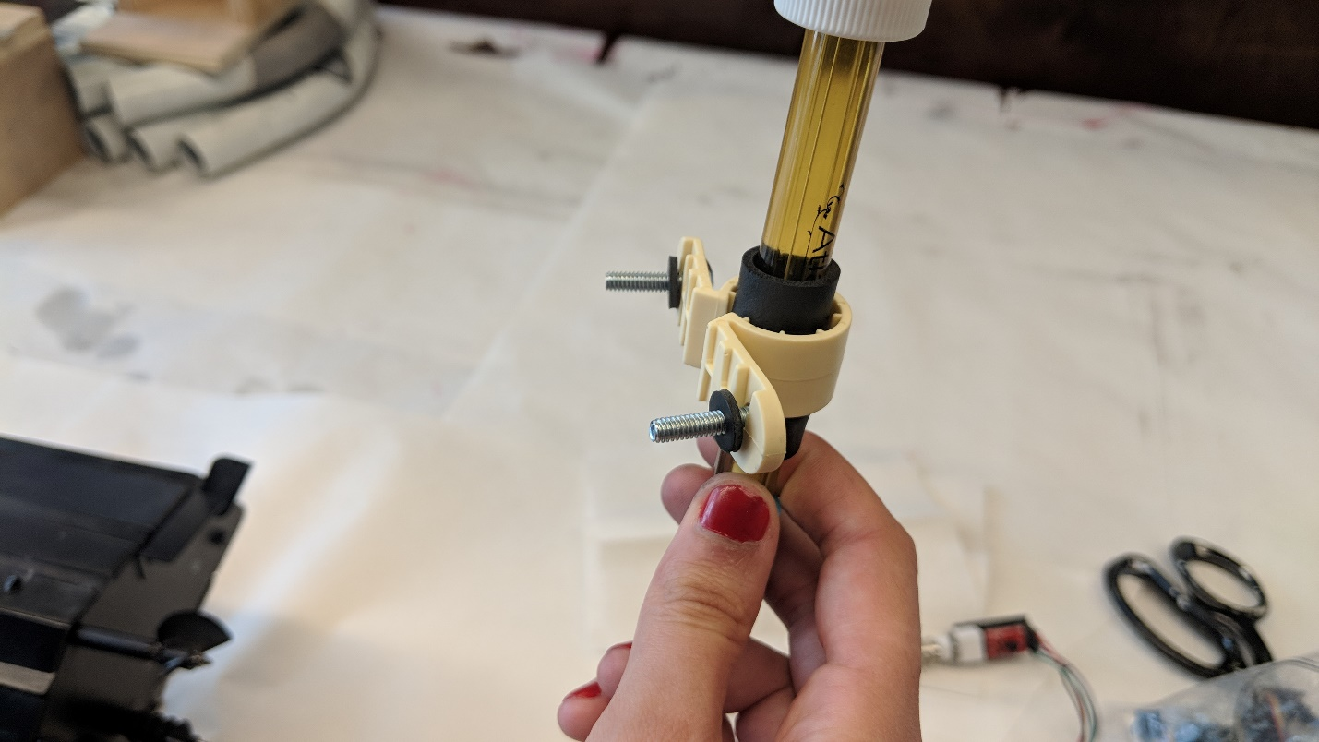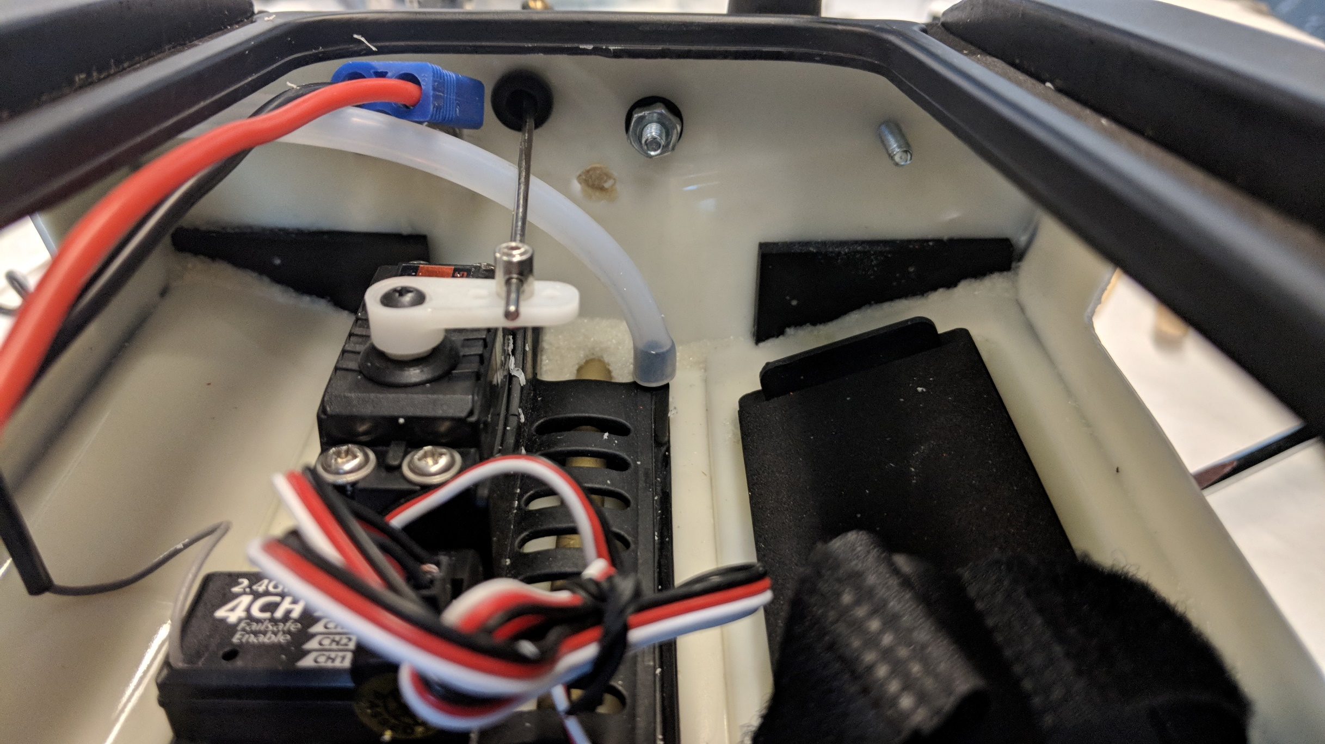

These images show how to screw on the pH clamp.

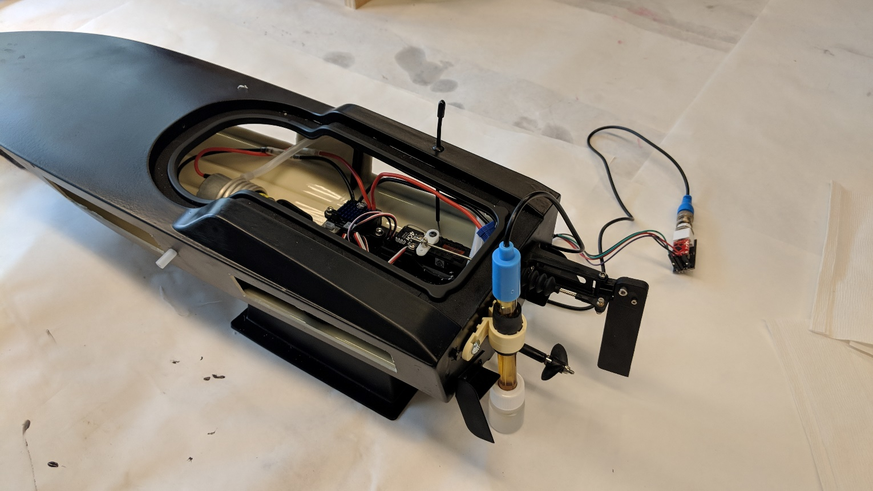

This is the pH probe after it’s been properly secured with screws and Loctite.

1. Thread the wire through the top LED panel cut-out.
2. Make sure to leave enough wire loose so we can take the top off of the boat.

## turbidity

1. 3-D print the boat attachment part for the 1/16-inch-thick turbidity sensor.

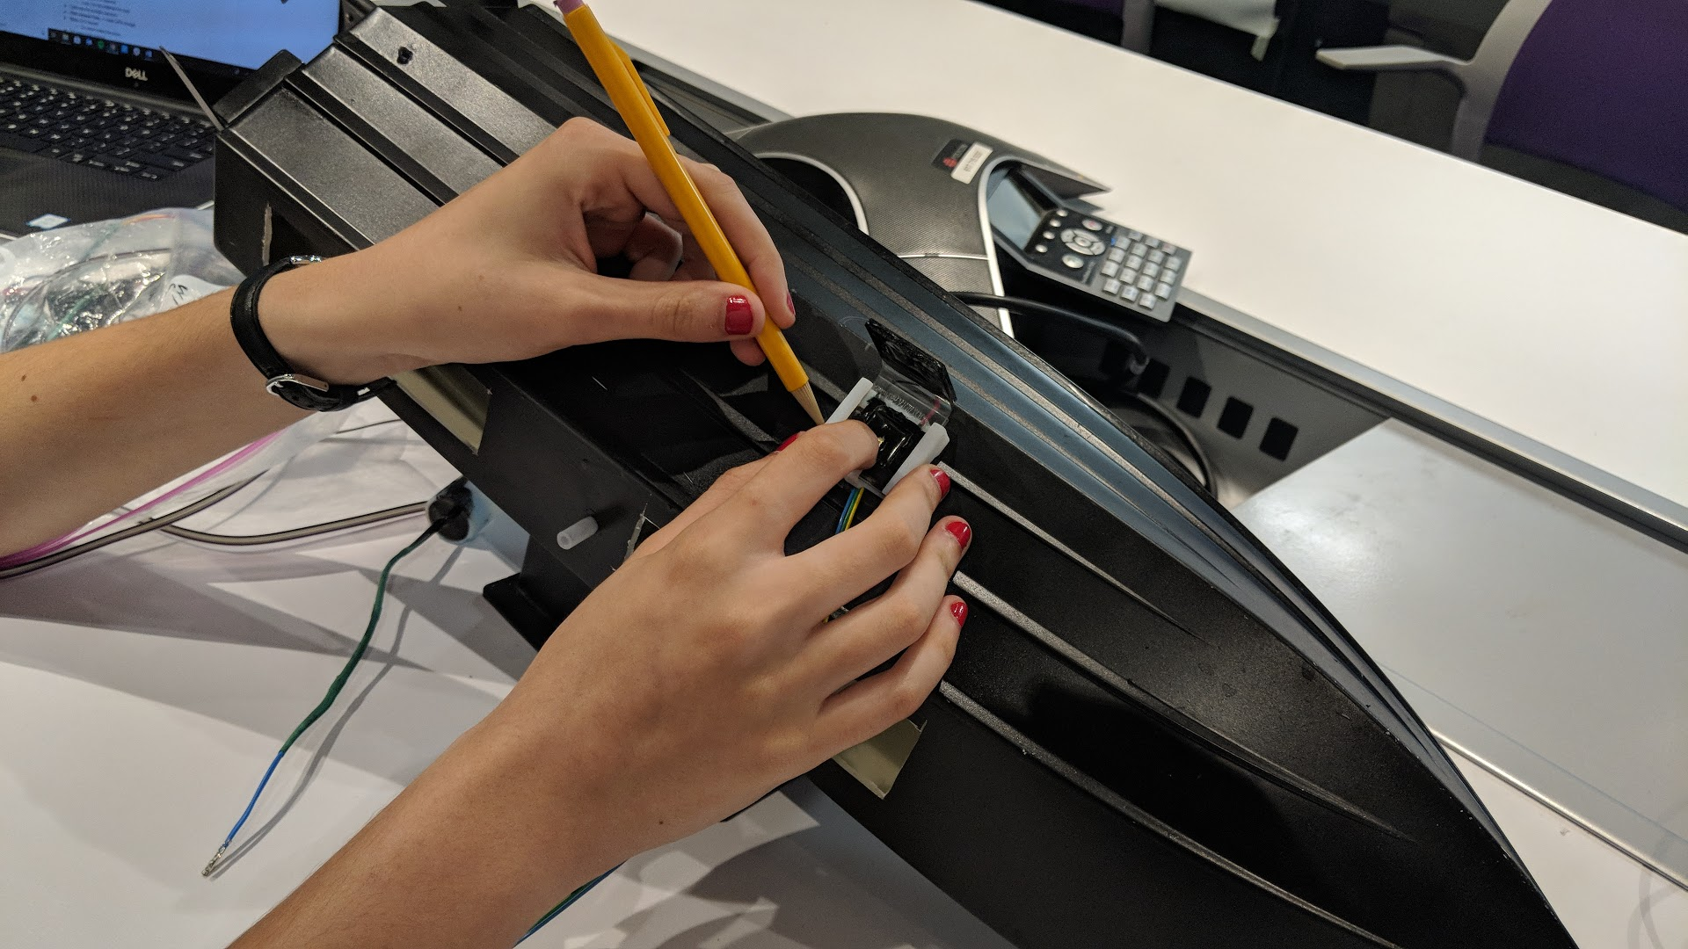

We traced the outside of the turbidity holder in pencil first, then outlined that sketch with blue tape for sanding.

1. Sand the boat until there is no paint where there will be epoxy. Wipe off any dust that accumulates.
2. Use your best judgement on whether to sand the 3-D printed part or not; it’s already a little rough.
3. Epoxy the part onto the boat.
   1. Use the plastic-plastic epoxy.

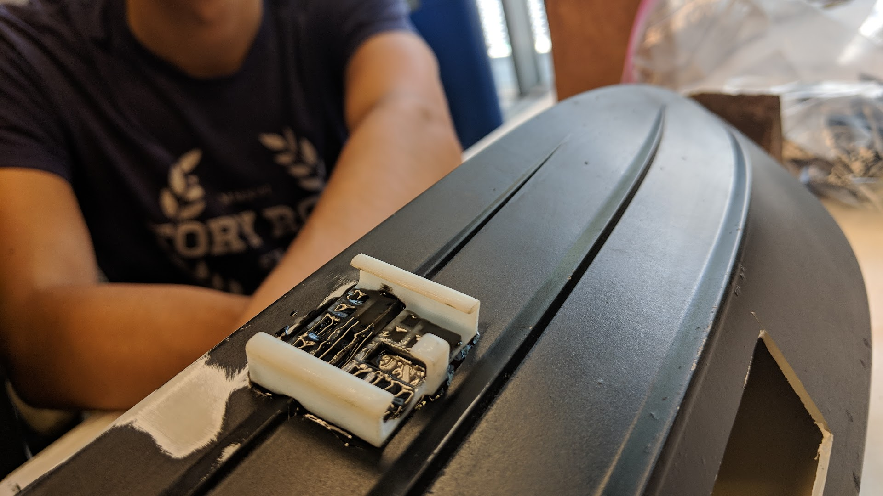

Our epoxied turbidity boat attachment.

1. Melt a hole for the wires using the soldering iron from the outside of the boat.
   1. Make the hole just large enough for the wires to get through.

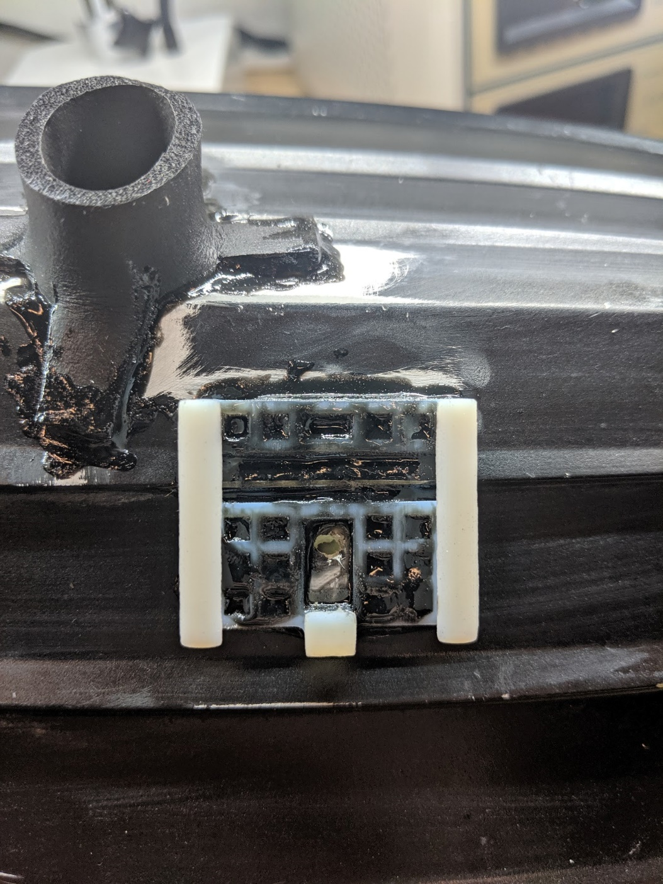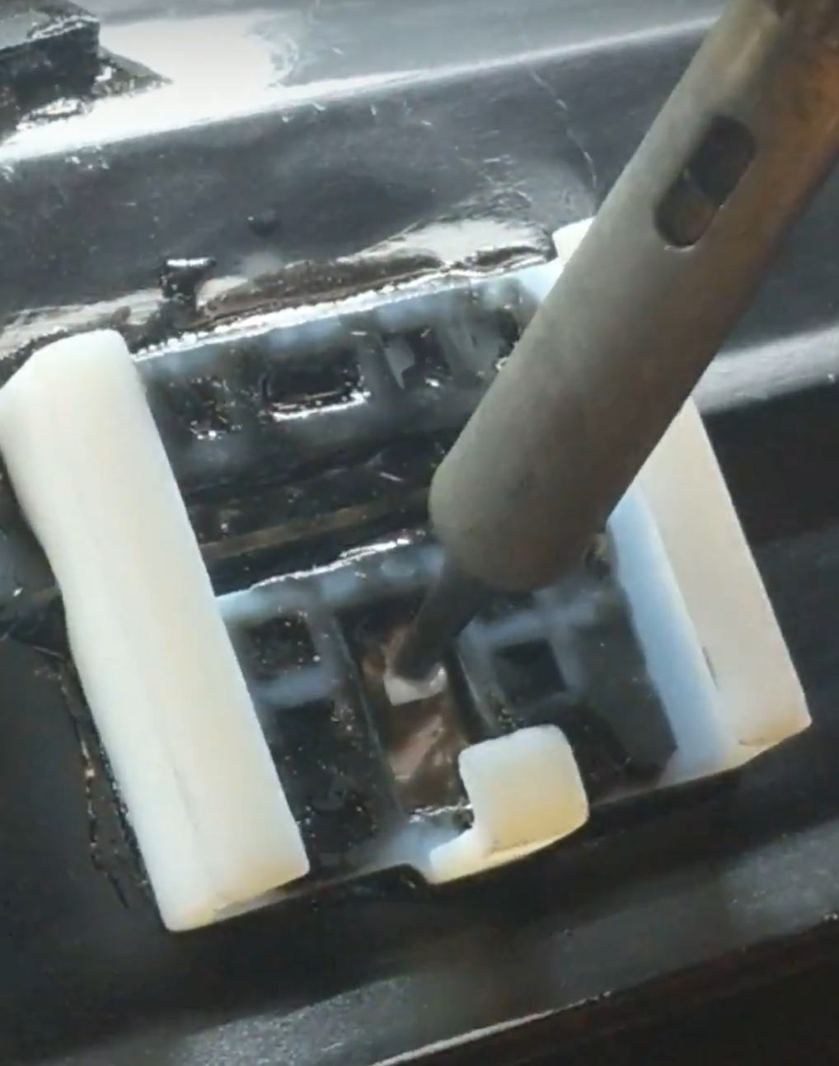

The melted hole for the turbidity sensor, and the process of melting it.

1. Cut out a piece of foam board to slot into the boat attachment while there is no sensor in it to help protect it.
2. Attach the header on the end of the wires once the sensor is installed.
3. Use silicone glue to seal the wires in the hole.
   1. At this step you can reinforce the wires of the turbidity sensor using plastic-plastic epoxy on top of the heat shrink.

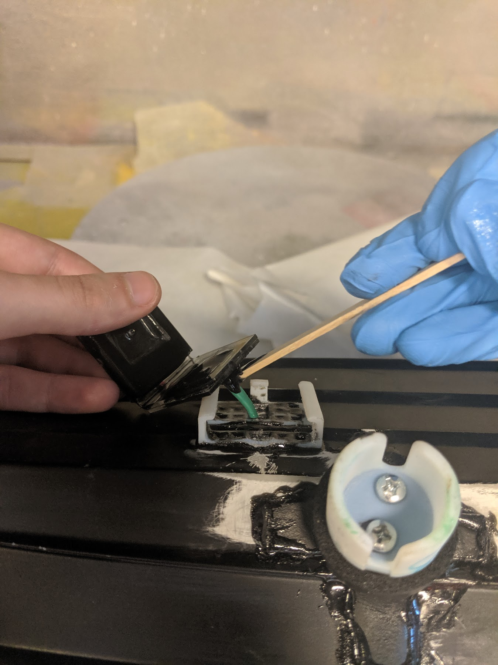

Applying epoxy to the turbidity wires to strengthen them before we seal them in the hole.

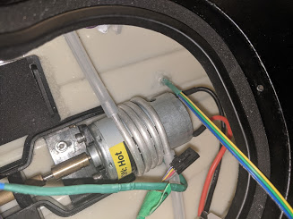

The sealed hole for the turbidity sensor.

## conductivity

1. Cut the probe holder out of the rubber tubing using the template.

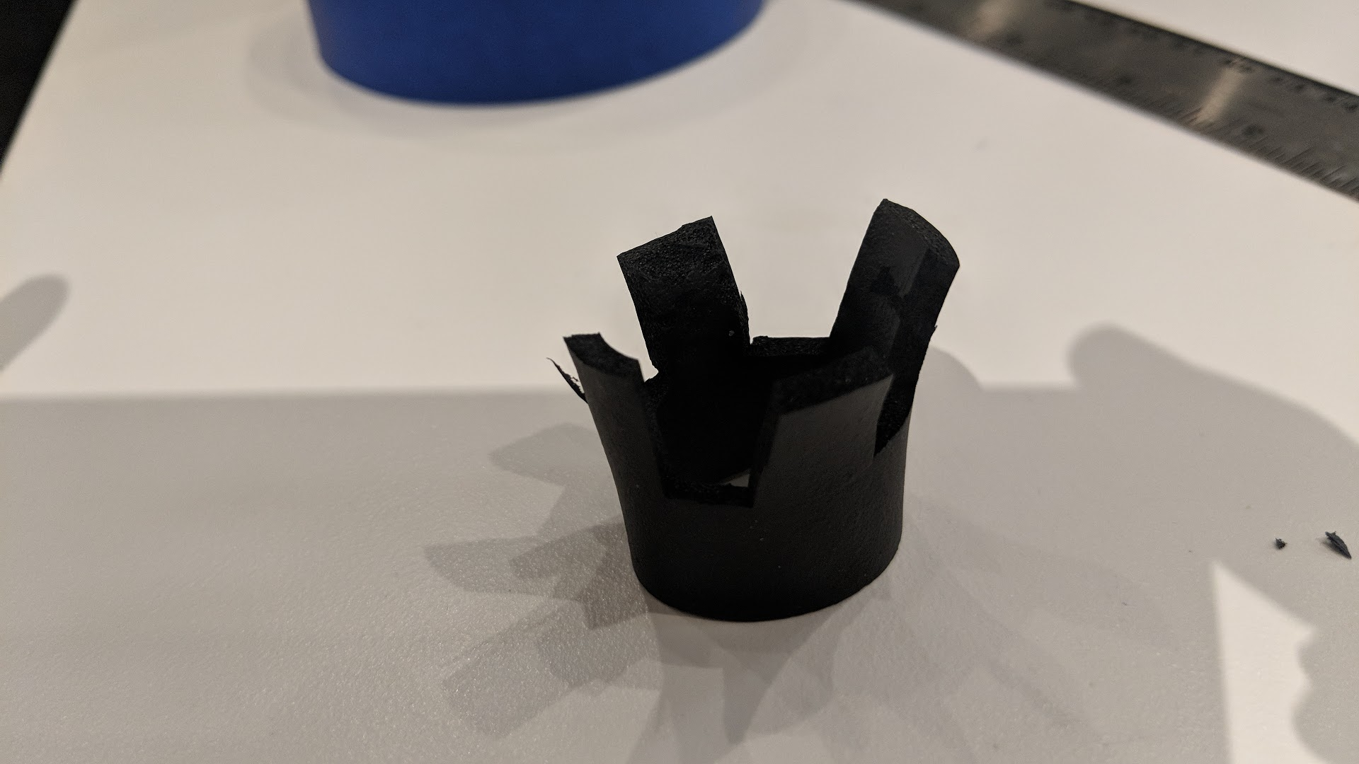

This is the tubing after it’s been cut according to the template.

1. ‘Sand’ the rubber so that the foam interior is exposed; the epoxy doesn’t adhere well to the outside coating.
2. Sand the boat until there is no paint where there will be epoxy. Wipe off any dust that accumulates.

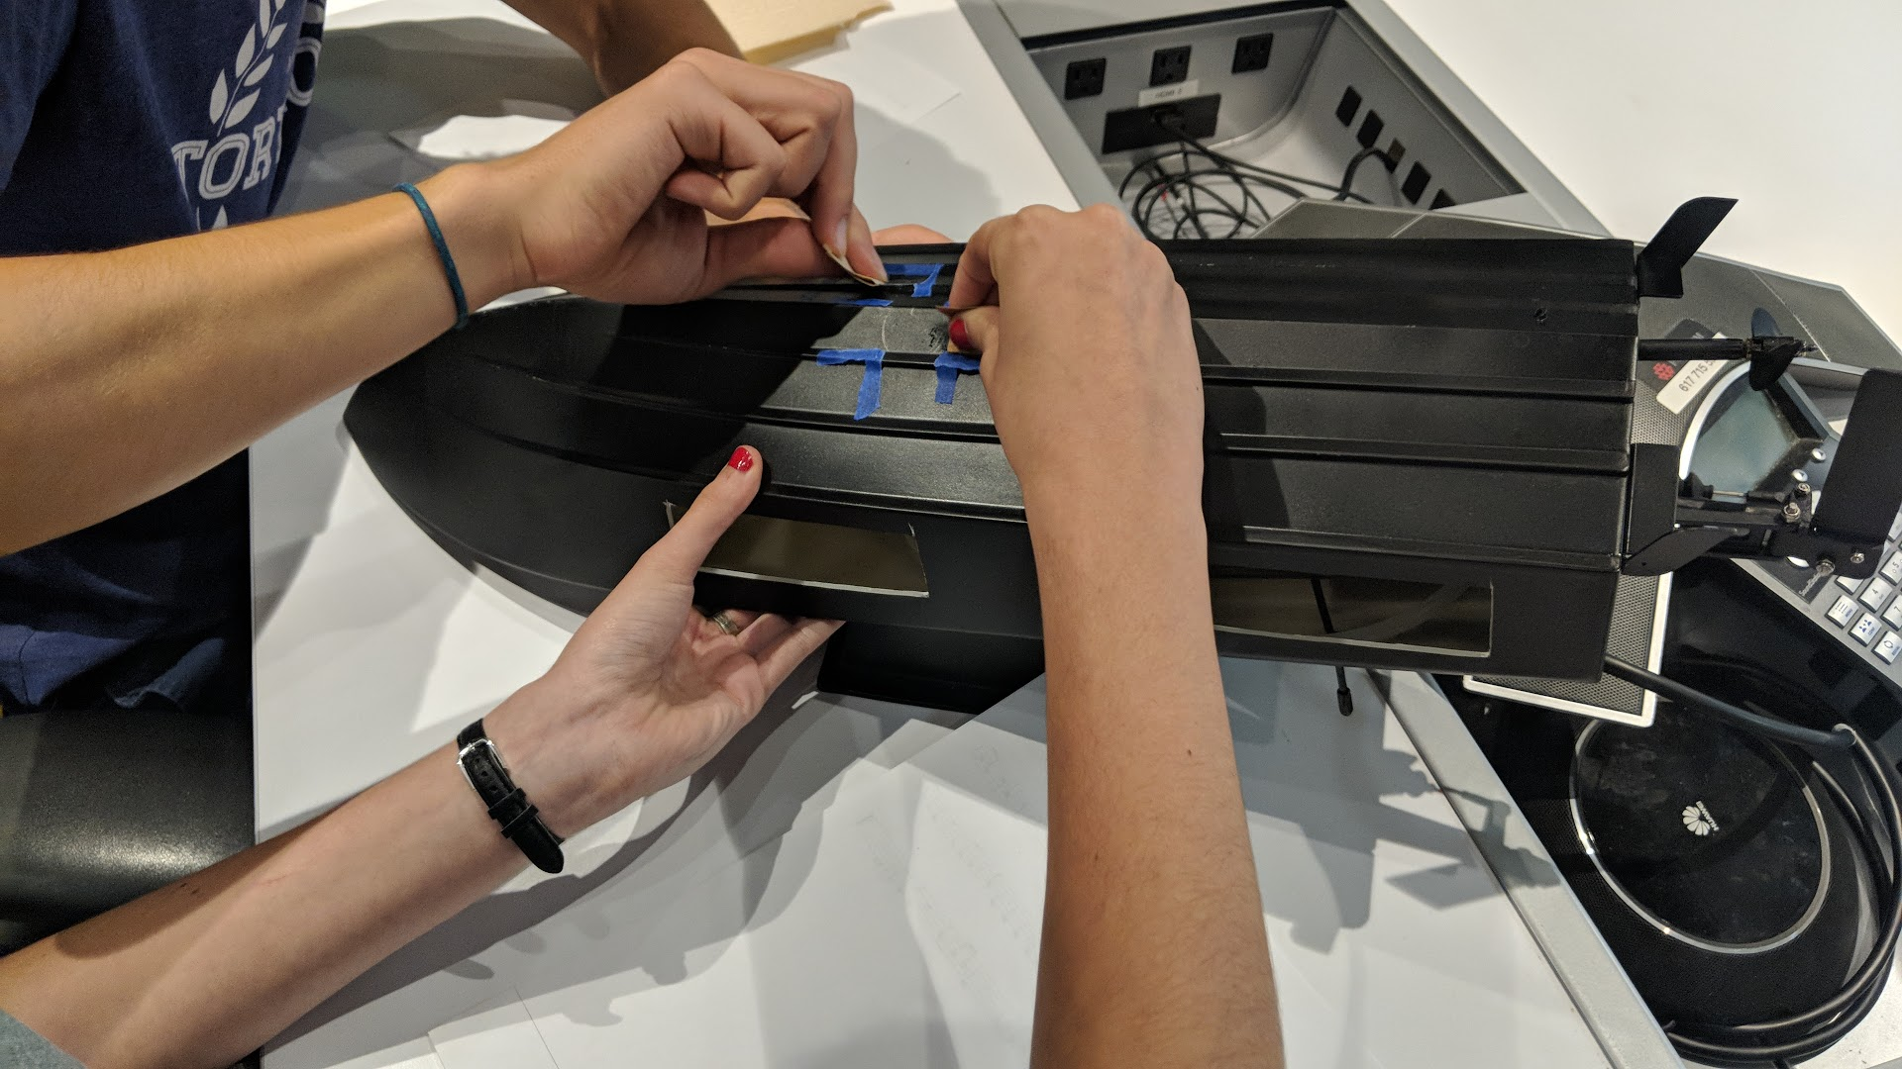 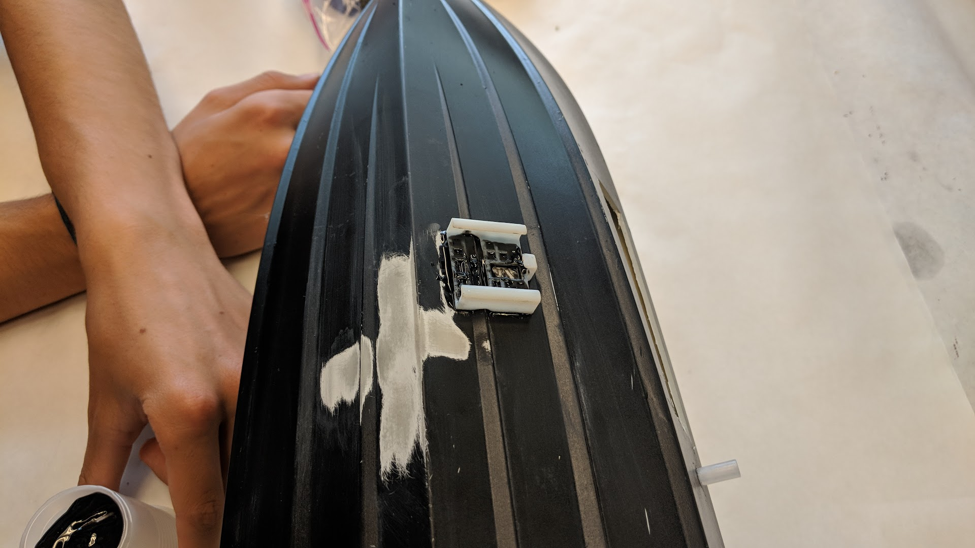

We traced the outside of the conductivity holder in pencil first, then outlined that sketch with blue tape for sanding.

1. Epoxy the rubber onto the boat. Hold the part manually for a few minutes, then use tape to hold it in place while it cures.

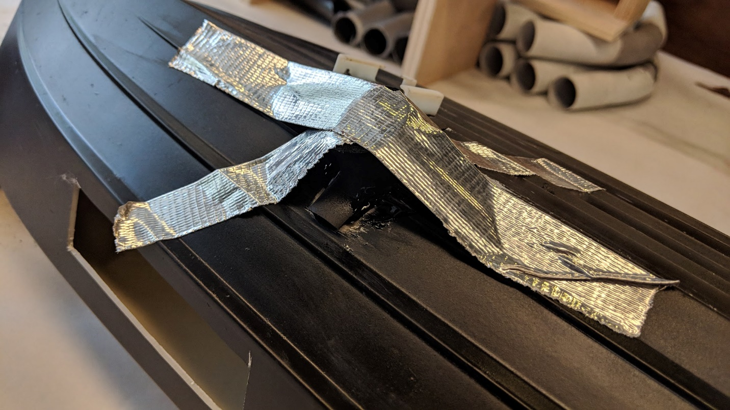

This is how we taped down the tubing to let the epoxy cure for a while.

1. Melt a hole for the wires using the soldering iron from the outside of the boat.
   1. Make the hole just large enough for the wires to get through.

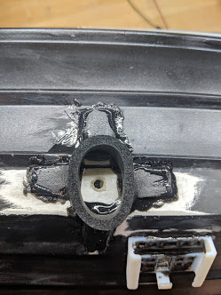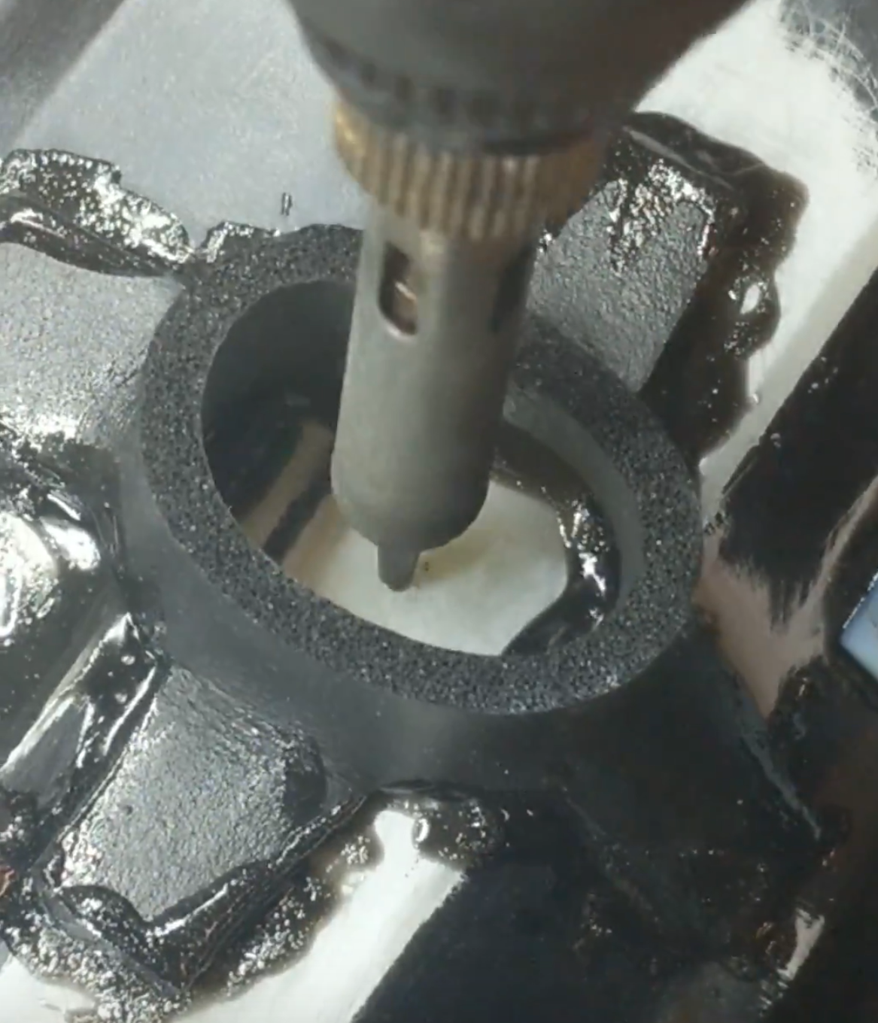

The melted hole for the conductivity sensor, and the process of melting it.

1. Attach the header on the end of the wires once the sensor is installed.
2. Use silicone glue to seal the wires in the hole.

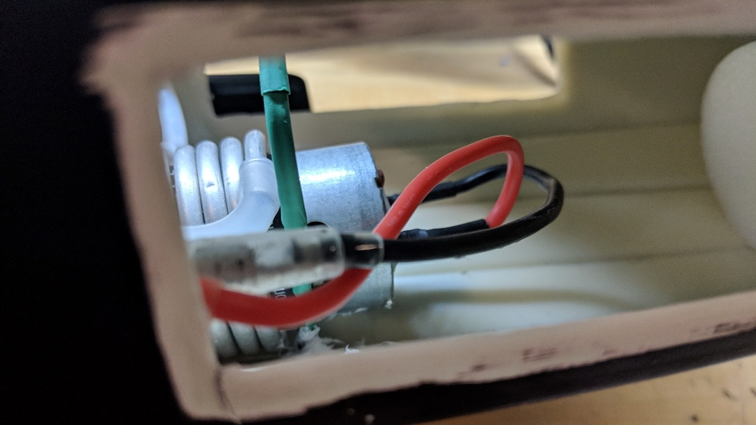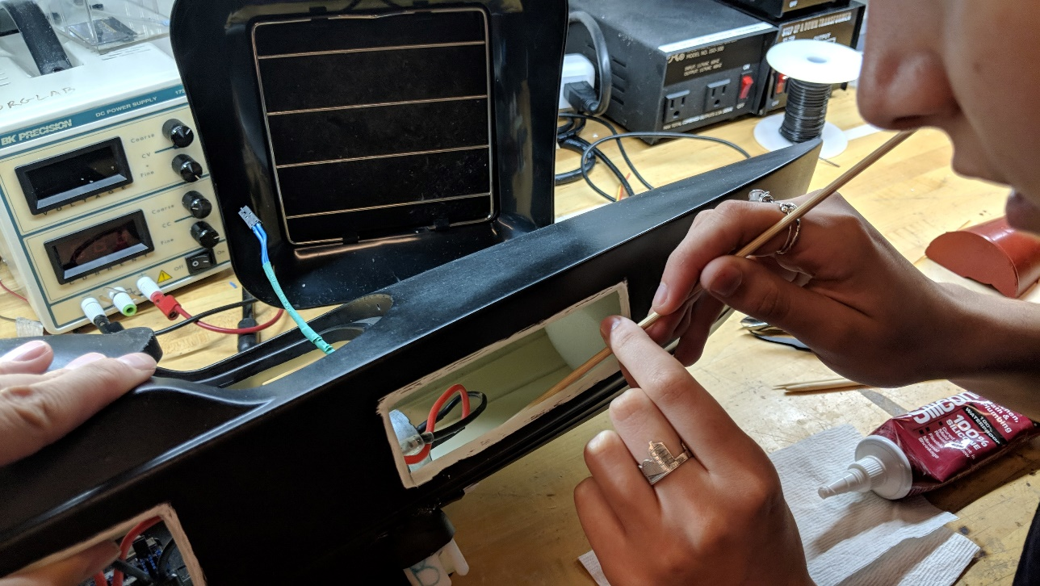

The sealed hole for the conductivity sensor, and the process of sealing it.

## temperature

1. Melt a hole for the wires using the soldering iron. Start from inside the boat so you can be sure not to hit any other parts.
   1. Make the hole just large enough for the wires to get through.

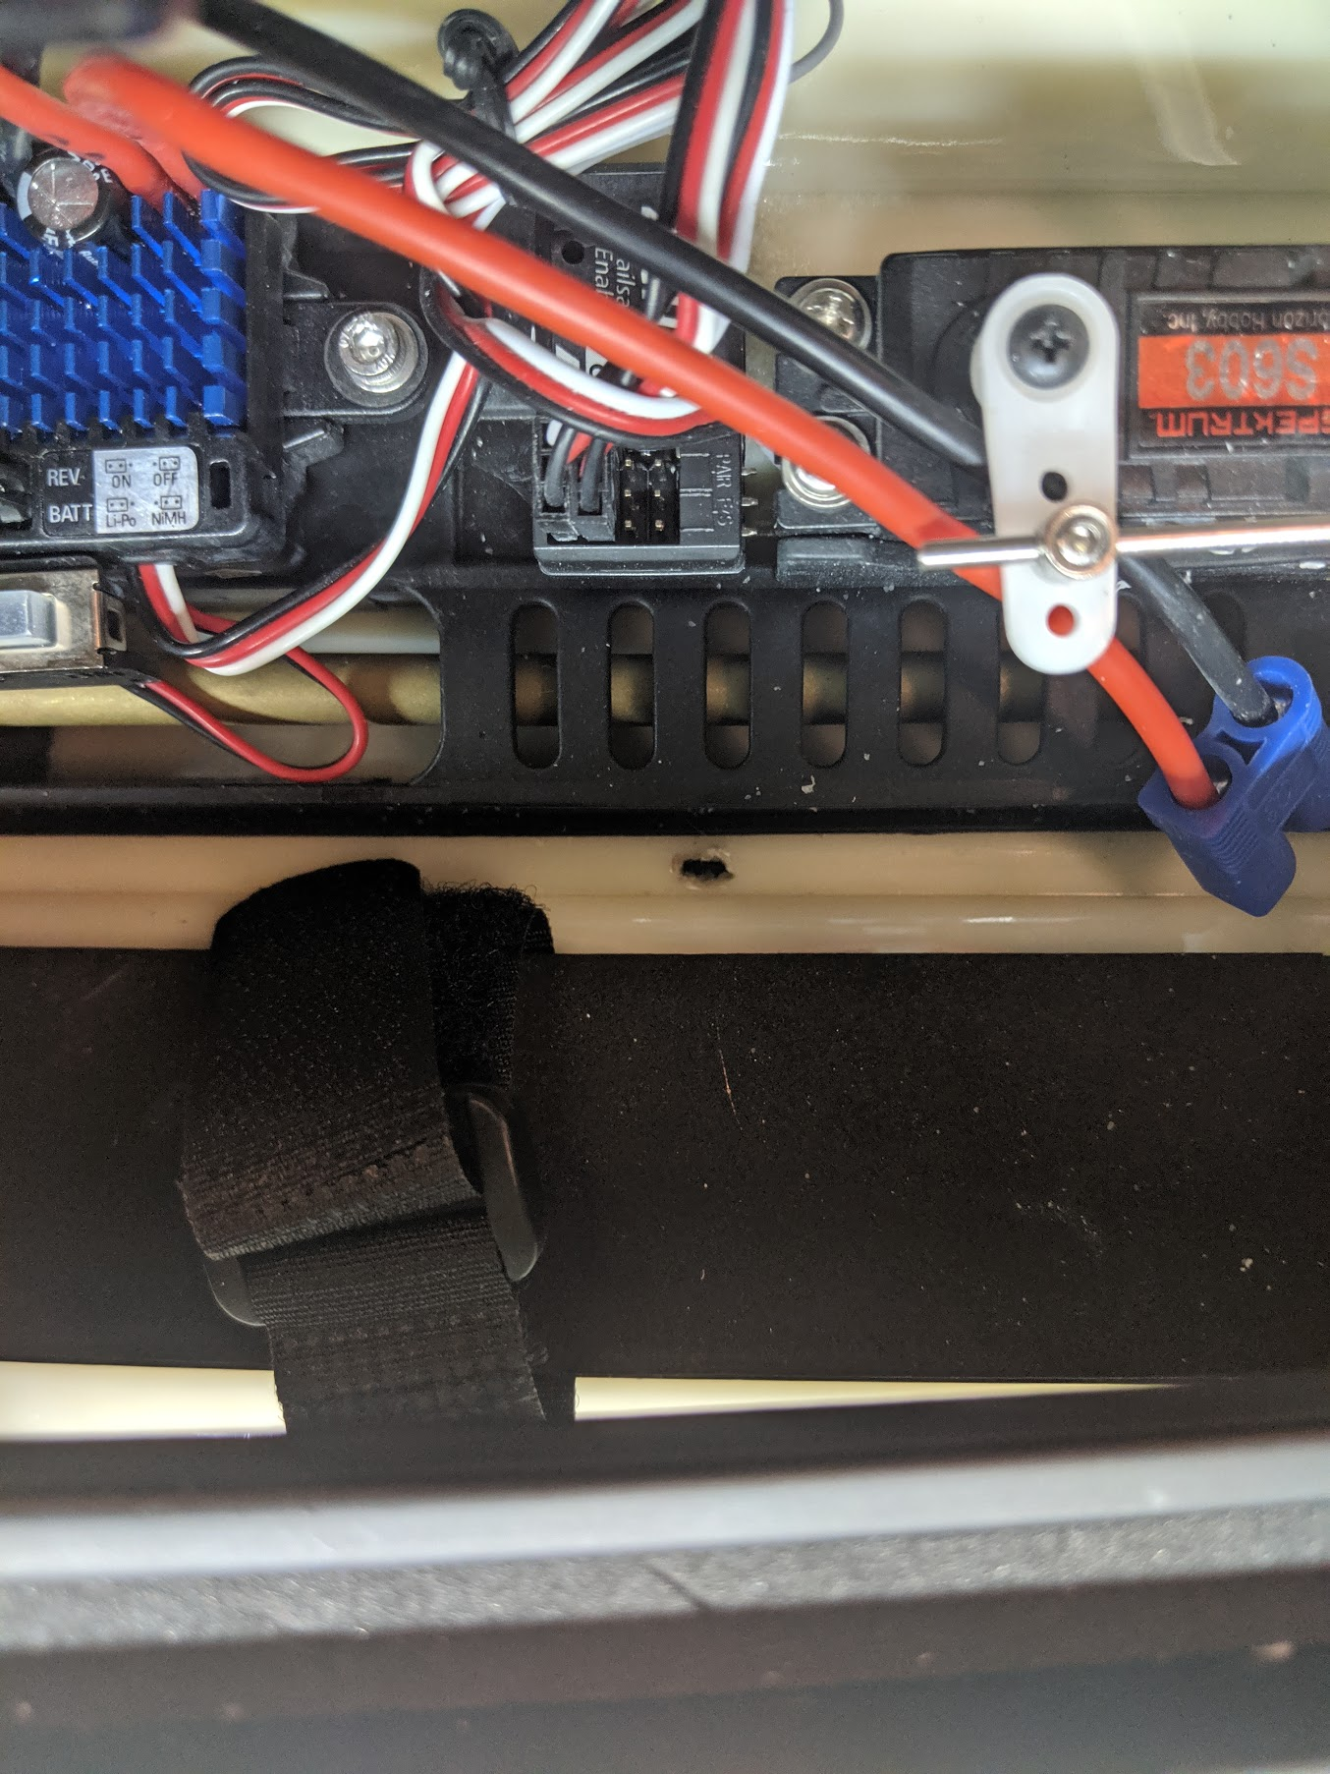

The melted hole for the temperature sensor.

1. Attach the header on the end of the wires once the sensor is installed.
2. Use silicone glue to seal the wires in the hole.

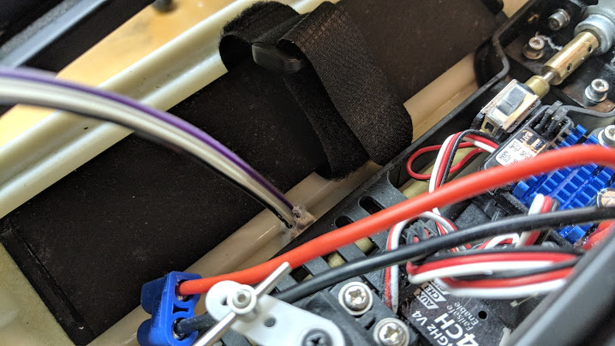

The sealed hole for the temperature sensor.